 | .corby . Kingswood  Hazel leys benfield  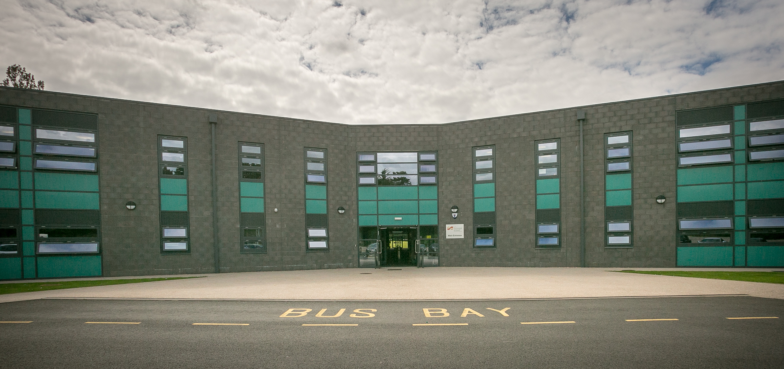  engeland  school | .Kingswood .corby  Hazel leys benfield  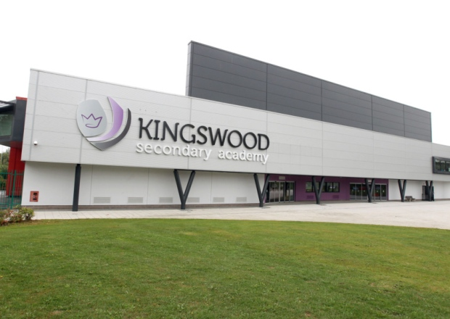  engeland  school
.Hazel leys .corby  .Kingswood benfield  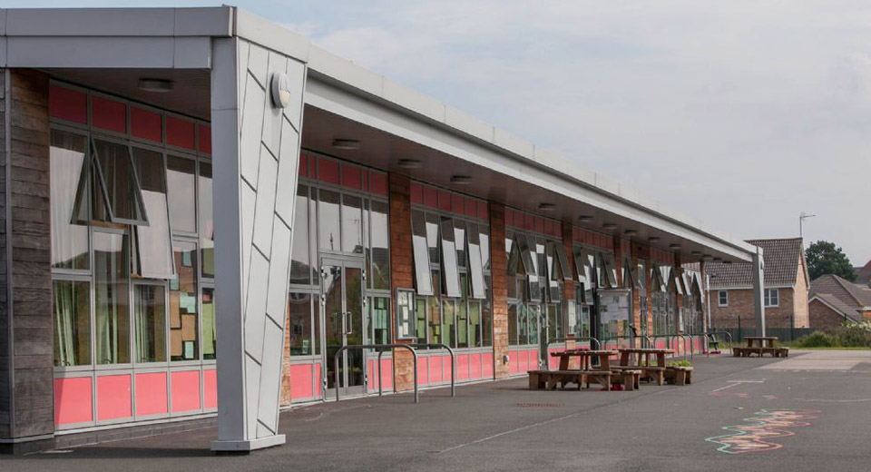  engeland  school | . benfield .corby  .Kingswood Hazel leys  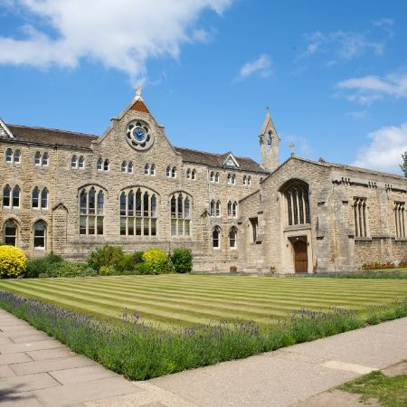  engeland  school | Wendy’s 5 guys  The bell the cottage  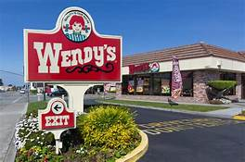  engeland  restaurant
5 guys wendy’s  The bell the cottage    engeland  restaurant | The bell 5 guys  Wendy’s the cottage  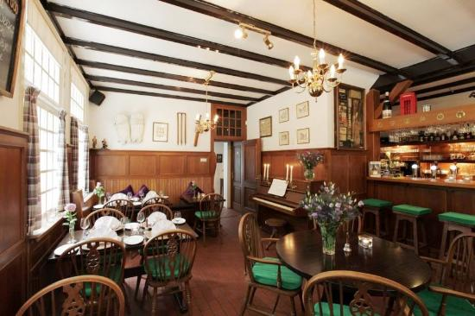  engeland  restaurant | The cottage wendy’s  5 guys the bell  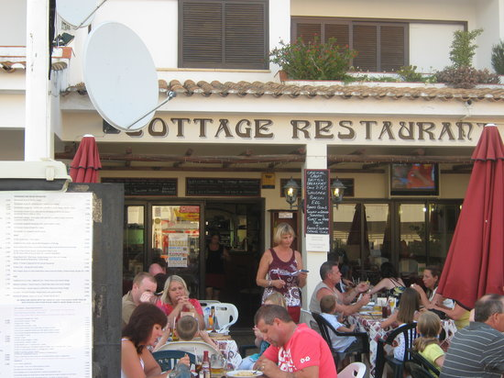  engeland  restaurant

